Task description
Site for testing: https://practice.qabrains.com/ecommerce
UC-1 Test Login form with wrong credentials:
oEnter any credentials that are not listed in “Accepted email” and “Password” sections into "Email" and "Password" fields.
oHit the "Login" button.
oCheck the error messages: "Username is incorrect" and “Password is incorrect.”.
UC-2 Test favorite products:
oEnter any credentials from “Accepted email” and “Password” sections into "Email" and "Password" fields.
oMark a few items as favorites.
oClick on the email in the top right corner and click “Favorites”.
oCheck that previously selected items are displayed on Favorites page.
UC-3 Test products ordering:
oEnter any credentials from “Accepted email” and “Password” sections into "Email" and "Password" fields.
oOrder products by price from low to high.
oCheck that all products are ordered according to selected option.
Provide possibility to execute tests in parallel, add logging to track execution flow and use data-driven testing approach.
Make sure that all tasks are supported by these 3 conditions: UC-1; UC-2; UC-3.
Please, add task description as README.md into your solution!
To perform the task use the various of additional options:
Test Automation tool: Selenium WebDriver;
Browsers: 1) Chrome; 2) Edge;
Locators: XPath;
Test Runner: xUnit;
Assertions: FluentAssertions;
[Optional] Patterns: 1) Builder; 2) Adapter; 3) Bridge;
[Optional] Test automation approach: BDD;
[Optional] Loggers: NLog.
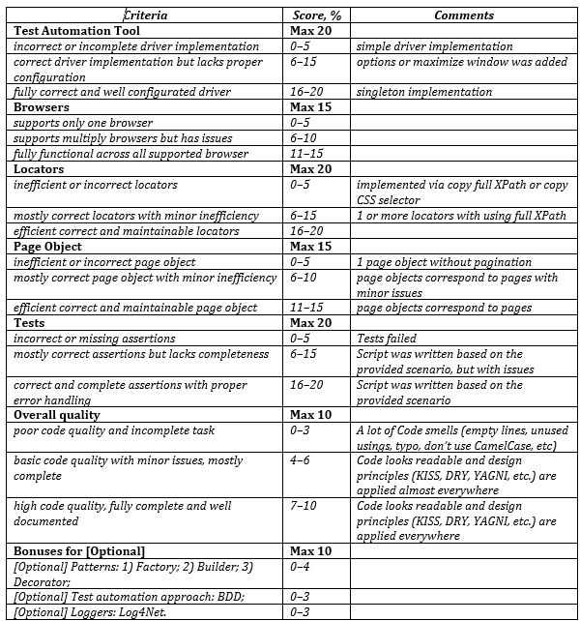
//div[contains(@class, 'flex flex')]/a[contains(@class, 'text-lg')]
//div[contains(@class, 'flex flex')]//button[@class = ' cursor-pointer']

Please, add task description as README.md into your solution!
To perform the task use the various of additional options:
Test Automation tool: Selenium WebDriver;
Browsers: 1) Chrome; 2) Edge;
Locators: XPath;
Test Runner: xUnit;
Assertions: FluentAssertions;
[Optional] Patterns: 1) Builder; 2) Adapter; 3) Bridge;
[Optional] Test automation approach: BDD;
[Optional] Loggers: NLog. .
есть еще критерии:
Test Automation Tool - fully correct and well configurated driver (singleton implementation)
Browsers - fully functional across all supported browsers
Locators - efficient correct and maintainable locators
Page Object - efficient correct and maintainable page object
Tests - correct and complete assertions with proper error handling (script was written based on the provided scenario)
Overall quality - high code quality, fully complete and well documented (Code looks readable and design principles (KISS, DRY, YAGNL, etc.) are applied everywhere)
Patterns - factory, builder, decorator
Test automation approach - BDD
Loggers - Log4Net

Can you help us to create a list of topics
For example

1. SDLC & Role of Tester
- SDLC models (Waterfall, Agile)
- STLC phases
- Role of QA in a team
- Communication (QA, Dev, BA)

2. Testing Types, Levels, Methods
- Testing levels (unit, integration, system, acceptance)
- Testing types (functional vs non-functional)
- Black / White / Grey box
- Verification vs Validation

3. Test Planning
- Test plan vs test strategy
- Scope, risks, priorities
- Entry/exit criteria

4. Requirements
- Types of requirements (functional / non-functional)
- User stories & acceptance criteria
- Quality of requirements
- Working with unclear requirements

5. Test Documentation
- Test cases vs checklists
- Test suites
- Traceability (RTM)

6. Test Design Techniques
- Equivalence Partitioning
- Boundary Value Analysis
- Decision tables / State transitions
- Exploratory testing

7. Defect Management
- What is a bug
- Bug report structure
- Bug lifecycle
- Severity vs Priority

8. Test Reporting
- Test status report
- Test result report
- Basic metrics (coverage, defects)

9. Estimation
- Why estimation is needed
- Basic techniques (WBS, 3-point)
- Estimation in Agile

